**Multidisciplinary Seminar Session 6 2021.3.4**

**Multiple Model Adaptive Control for Passive Rotating Spherical Shell UAV   
in Gazebo Simulation**Graduate School of Information Science, Applied Information Science

Human-Robot Informatics-Tadokoro Lab, Pongsakorn Songsuroj C0IM4022

**1. Introduction**

Recently, UAV, or so-called “Drone” is widely used in various fields of applications, including inspection work. In the inspection work, the UAV needs to get close to the inspected object, which can lead to an unexpected crash during flight. Passive Rotating Spherical Shell (PRSSUAV) in Fig. 1 is introduced to protect UAV core structure and other moving parts such as rotors and propellers. The specification of PRSSUAV is that it has three degrees of freedom, so it can rotate along the flat surface while its body position remains intact. Moreover, it safely protects the core structure of the UAV when landing on rough terrain.

Although PRSSUAV provides many benefits for inspection applications, it requires specific control methods for different types of movements, consisting of free flight (FF), rolling flight (RF), and deadlock (DL). Free flight (FF) is when the PRSSUAV behaves similarly to a conventional UAV. Rolling flight (RF) is when the PRSSUAV is moving along the flat surface such as inspected wall or roof. In this movement mode, the rotating shell of the UAV always needs to contact the object. The last movement mode is Deadlock (DF) which can be used when PRSSUAV gets stuck or it holds a position for a given period. With these three unique movements, not only do they require particular control rules, but it also needs to be able to switch between one another mode during flight. Thus, this research proposes the switching method that is capable of changing control rules based on its current behavior. The PRSSUAV model and experimental environment were developed and tested in Gazebo simulation.

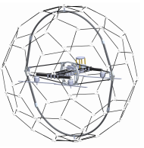

Fig 1. Structure of PRSSUAV

**2. Methodology**

**2.1 Mathematical Modelling**

Fig. 2 shows several states of PRSSUAV consisting of Free flight state, Rolling flight state, and Deadlock state. The motion equation for each flight state can be obtained by Eq (1) for FF, Eq (2) for RF, and Eq (3) for DL.

$\ddot{x}=\frac{b}{m}u- \frac{c}{m}\left|\dot{x}\right|\dot{x}+\frac{d}{m}$ (1)

$\ddot{x}=\frac{mr^{2}}{I+mr^{2}}\left(\frac{b}{m}u- \frac{c}{m}\left|\dot{x}\right|\dot{x}+\frac{d}{m}\right)$ (2)

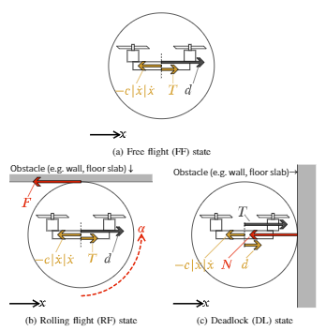

Fig 2. State of PRSSUAV

$\ddot{x}=\frac{b}{m}- \frac{c}{m}\left|\dot{x}\right|\dot{x}+\frac{d}{m}-\frac{N}{m}$ (3)

**2.2 Controller Design**

In FF state, RL state, and DF state, they share the same position controlling method as shown in Eq. (4). The output received after this process is velocity reference ($v_{ref}$) which will be used in the velocity controller. Next, to compute thrust setpoint ($u$), each state has its own different control rules suitably adjusted for a particular flight task. The equation of velocity controller can be found in Eq. (5), Eq. (6), and Eq. (7) for FF state, RL state, and DF state, respectively.

$v_{ref}=λ_{pos}e_{pos}+{\dot{x}}_{ref}$ (4)

$u=\hat{P}(e_{pos}+λ_{vel}e_{vel}+{\dot{v}}_{ref}+\hat{C}\left|v_{uav}\right|v_{uav}-\hat{D})$ (5)

$u={\hat{P}}_{ff}\{\hat{ρ}(e_{pos}+λ_{vel}e_{vel}+{\dot{v}}_{ref})+\hat{C}\left|v_{uav}\right|v_{uav}-\hat{D}\}$ (6)

$u={\hat{P}}_{ff}(e_{pos}+λ_{vel}e_{vel}+{\dot{v}}_{ref}+{\hat{C}}_{ff}\left|v_{uav}\right|v_{uav}-{\hat{D}}_{ff})$ (7)

The multiple-model adaptive control method has two types of controller based on parameter estimation function. First, static controller, which does not estimate any movement parameters, but uses only pre-defined parameters. Second, dynamic controller, which always estimates UAV parameters during flight time.

The overall control system of the multicopter is showed in Fig. 3. Since PRSSUAV focuses on flying like a conventional UAV in Free flight (FF) mode and moving along the surface in the Rolling flight (RF) model, only position controller and velocity controller are involved in this aspect.

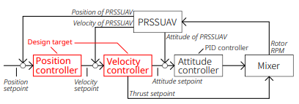

Fig 3. Overall Control System of Multicopter

In Fig.4, Six controllers are designed based on PRSSUAV behavioral movements. A flexible model (Dynamic) is included to cover other states which do not fall into Free flight, Rolling flight, or Deadlock one. The process starts from receiving the current position, current velocity, and position setpoint to output thrust setpoint for the next task. The estimator, then, calculates its estimated parameters for all six cases. To choose the controller for the next iteration, the supervisor selects the controller which has the lowest performance index ($u_{k}$) as shown in Eq. (4).

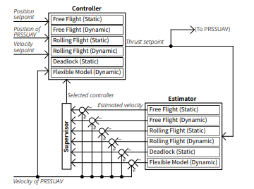

Fig 4. Overall Control System of Multicopter

$u_{k}=\int_{-t_{k-1}}^{t^{'}}{\exp\left(2λ_{per}τ\right)e_{est}^{2}}\left(t_{k-1}+τ\right)dτ$ (4)

**3. Simulation**

The model and world environment were built on Gazebo simulation with PX4 software in the loop as the firmware for PRSSUAV. The main airframe used in this model is quadrotor h, comprising four rotors. The rotating direction of each propeller of the quadrotor h airframe is opposite to that of quadrotor x. Next, its body is attached to three revolute joints. Every single joint represents one degree of freedom for roll, pitch, and yaw. For the outer shell, the actual structure uses a hollow sphere with pentagonal and hexagonal meshes. However, in simulation, due to the lack of this structure type, we chose a hollow sphere without meshes instead. The specifications and the PRSSUAV model in the simulation are displayed in Table.1 and Fig.5.

Table 1. Specifications of PRSSUAV

|  |  |
| --- | --- |
| Properties | Value |
| Radius of spherical shell | 1 m. |
| Weight | 3.15 kg. |
| Propeller radius | 0.125 m |

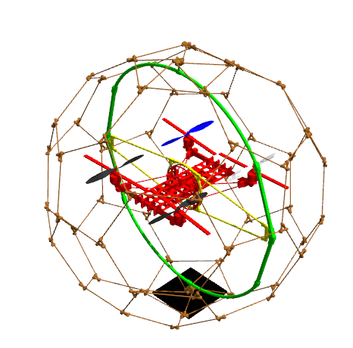

Fig 5. PRSSUAV model in Gazebo Simulation

In experimental environment, we applied square waypoint to PRSSUAV to let it move from origin to different corners and finally return to origin. In addition, along 2nd and 3rd waypoints, there are walls shown in Fig.6 set as obstacles to test PRSSUAV in Rolling flight (RF) mode and Deadlock (DL) mode.

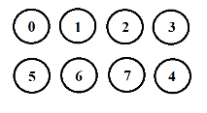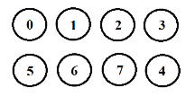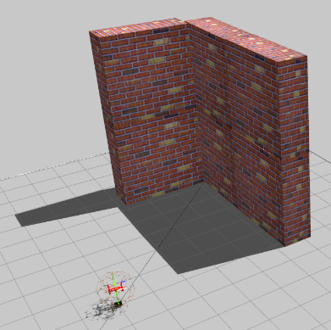

Fig 6. Tested Environment with Wall Obstacle

**4. Results**

PRSSUAV successfully follows the square trajectory and without crashing thanks to the outer spherical shell. According to Fig. 7, in 0-28s, it selected the Free flight (D) model after taking off and moving along the horizontal axis. However, before reaching the end of the 1st waypoint, it hit the wall, causing the model to change to Rolling flight (D) and Deadlock modes. PRSSUAV kept switching until it exited the obstacle path in 3rd waypoint and changed back to Free Flight mode. Lastly, PRSSUAV selected the Flexible model (D) for landing between 78s to 93s

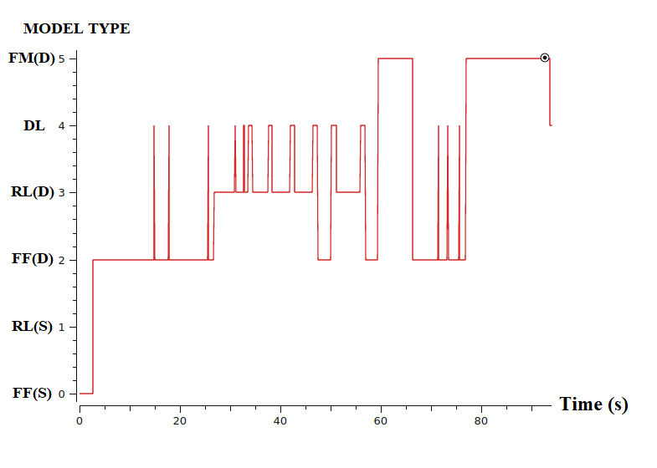

Fig 7. UAV Model Selection

**5. Conclusion**

From the result, PRSSUAV can switch between flight models according to its current movement types.

For future works, different types of switching algorithms will be considered to improve correctness and smoothness when switching between flight modes.

**6. Reference**

[1] A. Kalantari and M. Spenko, “Modelling and Performance Assessment of the HyTAQ, a Hybrid Terrestrial/Aerial Quadrotor,” IEEE Transactions on Robotics, vol 30, no. 5, pp. 127801285, Oct. 2014

[2] Z. T. Dydek, A. M. Annaswamy, and E. Lavretsky, “Adaptive Control of Quadrotor UAVs: A Design Trade Study With Flight Evaluations,” IEEE Transactions on Control Systems Technology, vol. 21, no. 4, pp. 1400-1406, Jul. 2013.

[3] M. Athans, D. Castanon, K Dunn, C. Greene, Wing Lee, N. Sandell, and A. Willsky, “The stochastic control of the F-8C aircraft using a multiple model adaptive control (MMAC) method-Part I: Equilibrium flight,” IEEE Transactions on Automatic Control, vol. 22, no. 5, pp. 768-780, Oct. 1977